**Run Leeds & Cross Flatts Park Run Volunteers**

**Water Splash Fun Run**

**Sunday 17th September 2023**

**Report by Victoria Cusack (Run Leeds Project Officer)**

**The Background**

When I first approached Cross Flatts Parkrun and the South Leeds Lakers run club to co-produce an event aimed at families and the local community of Beeston, Cross Flatts and Holbeck, my initial idea had been to put on a ‘paint the park’ type colour run. Inspired by the Hindu festival of Holi, and a colour run I had attended with my children at Leeds Beckett University a few years ago - this seemed the perfect visually appealing fun event for the Swim, Bike Run programme and Leeds Year of Culture 2023. Unfortunately, it quickly became apparent that this vision of colour would not be possible in Cross Flatts Park due to the potential environmental damage cited by LCC Parks and Gardens policy.

**The Water Splash Fun Run**

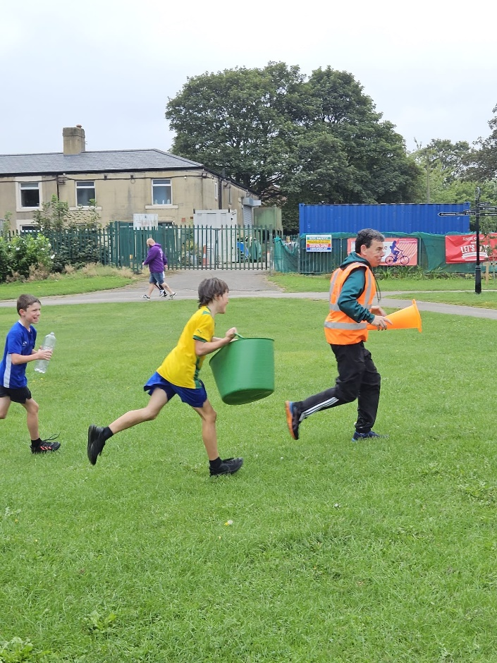

Not to be deterred, we put our thinking caps on, and came up with the Water Splash Fun Run instead. All the fun still that we wanted for a community and family event and less of a clean-up. Phil Hodgson, the director of parkrun and also a runner with the South Leeds Lakers was absolutely key in helping to plan and organise this event. It was decided that the event would take place just after the Junior Park run on a (hopefully), warm sunny morning in September. Taking advantage of the fantastic parkrun marshals and volunteers that would already be there to help out.

Little did they know what was in store for them 😊

Kirsty, our Run Leeds marketing expert, created this eye catching promotional material, which we used to advertise the event using a combination of media types – both digital using a number of social media forums, and traditional, using the South Leeds Life Newsletter, along with poster and fliers in key locations, to be seen by the local community .

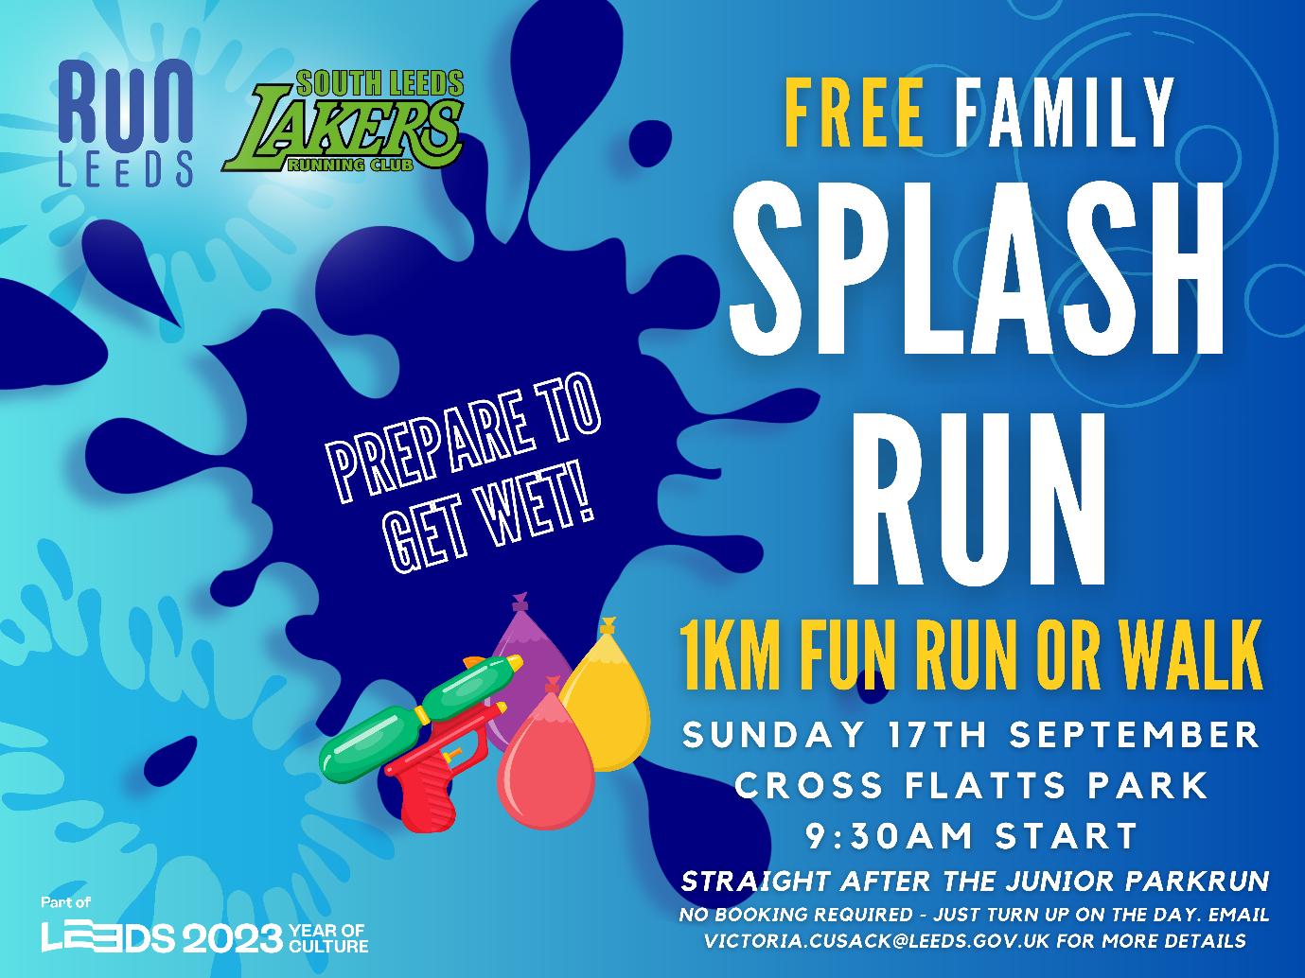

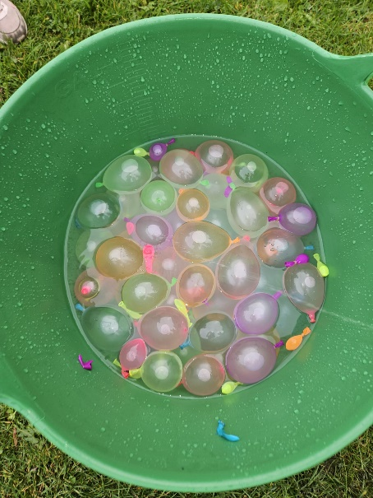We wanted to keep the event as accessible, and community focused as possible – with a 1km distance that could be run or walked. With no sign-up necessary and of course – totally free! The partners were clear that this was to be an event for the local community, encouraging families and young people to use their local park and check out parkrun, something for the regulars, but also something different to encourage some new faces.

With a plan, permission and a risk assessment in place, we just needed to work out logistics, and exactly how we would turn this fun run into a water splash event! With only one outdoor tap to access water and a 1km route to cover we needed some equipment!

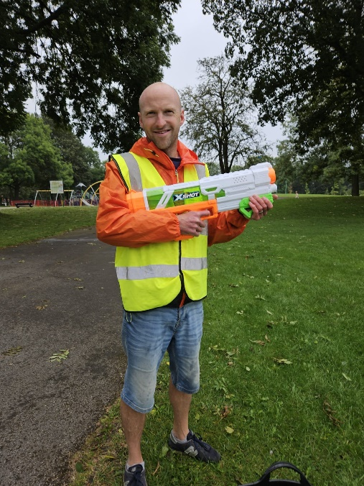

With 8 ‘water stations’ to be manned with marshals, we needed super soakers, water pistols, water balloons and a lot of trugs to strategically store water around the course.

It was an early start on that Sunday morning, filling up and transporting trugs, water balloons and super soakers around Cross Flatts Park. We just hoped it would stop raining by the time the event started.

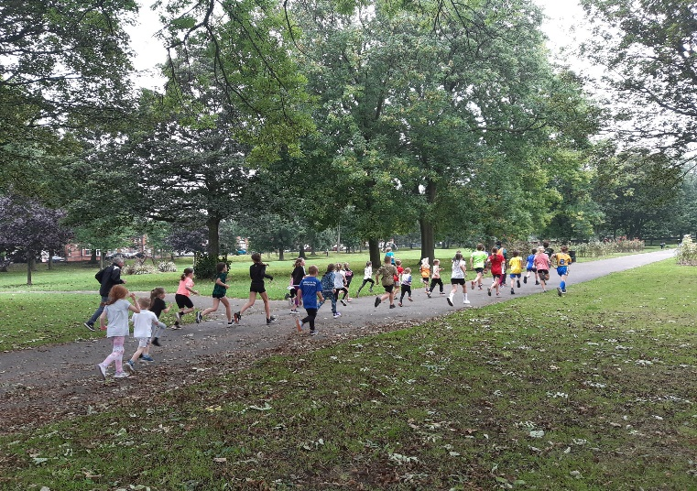

Luckily it did, and the children and their families started to arrive in time to run.

After a quick briefing, the participants got ready on the start line, arms filled with water balloons ready to retaliate (this was Phil’s idea I want to add!), they were off!

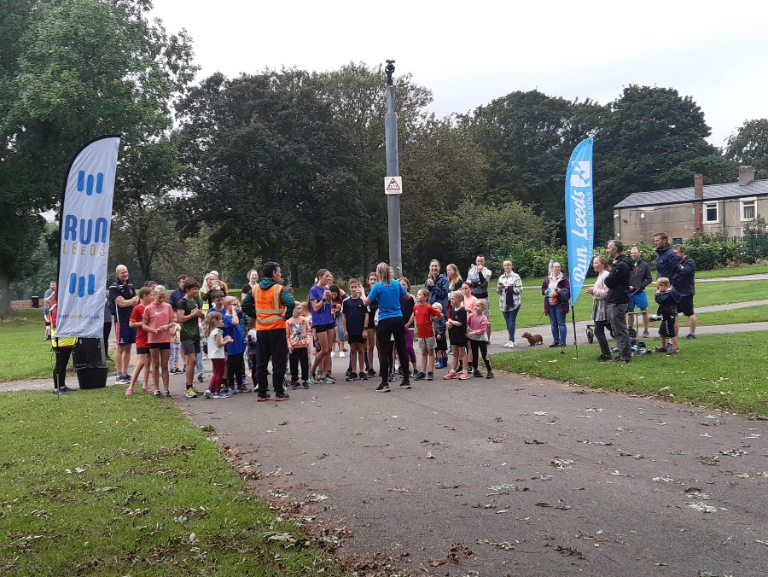Squeals of delight and laughter indicated that everyone was having a good time, so much fun many forgot that it was a run -two laps and many soaked people later the event was over.

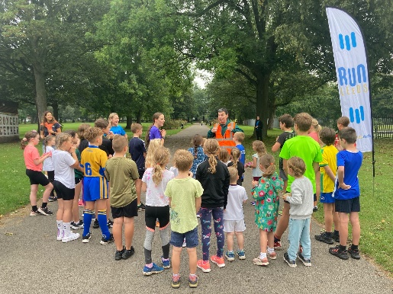

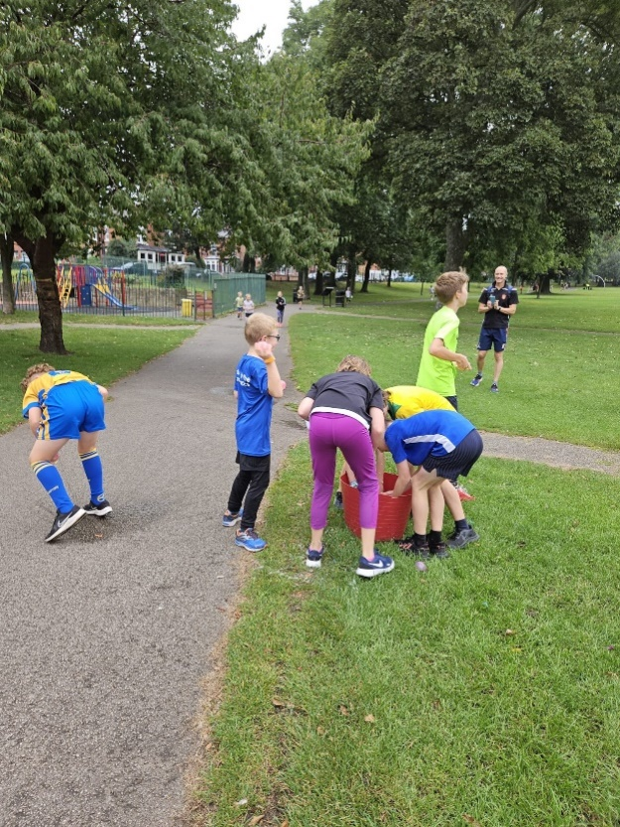

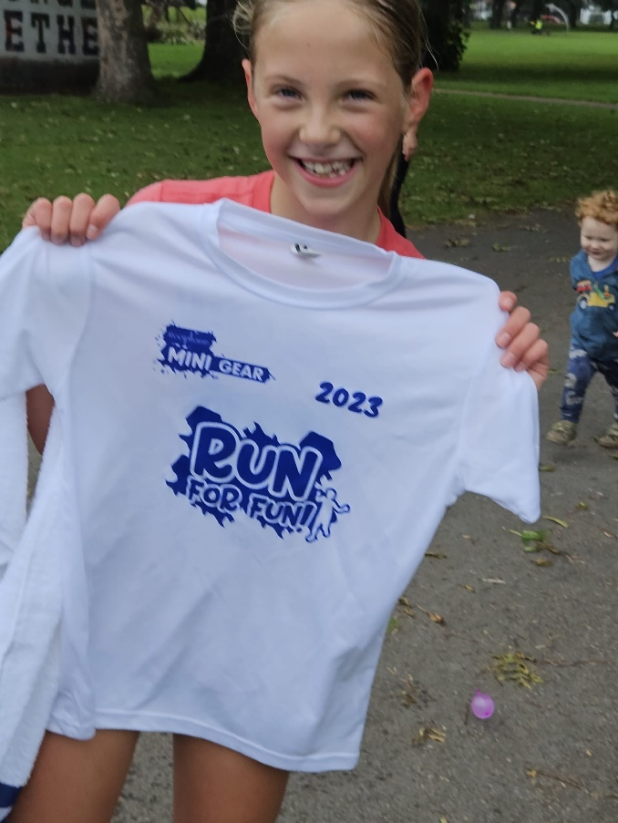Just as well my colleagues at Active Leeds, Karen and Libby had the foresight to accrue some donations of towels and T-Shirts to hand out at the end – these proved very popular!

After a collective clean-up effort to make sure the park was as we found it, and lots of happy thank yous from both children and parents, the event was over. This was definitely one of the most fun event I have organised for the Run Leeds Project to date!

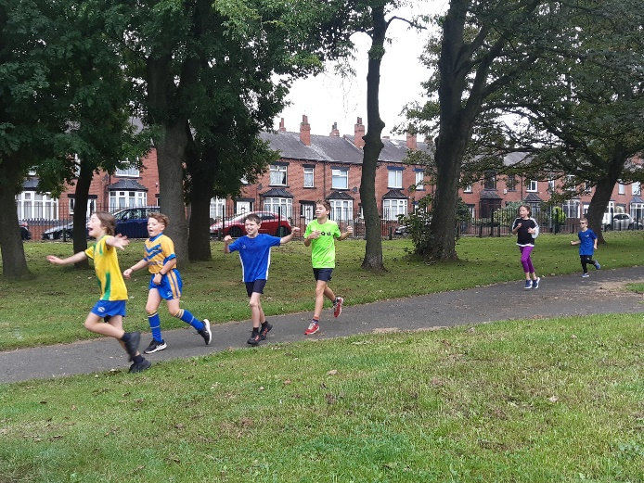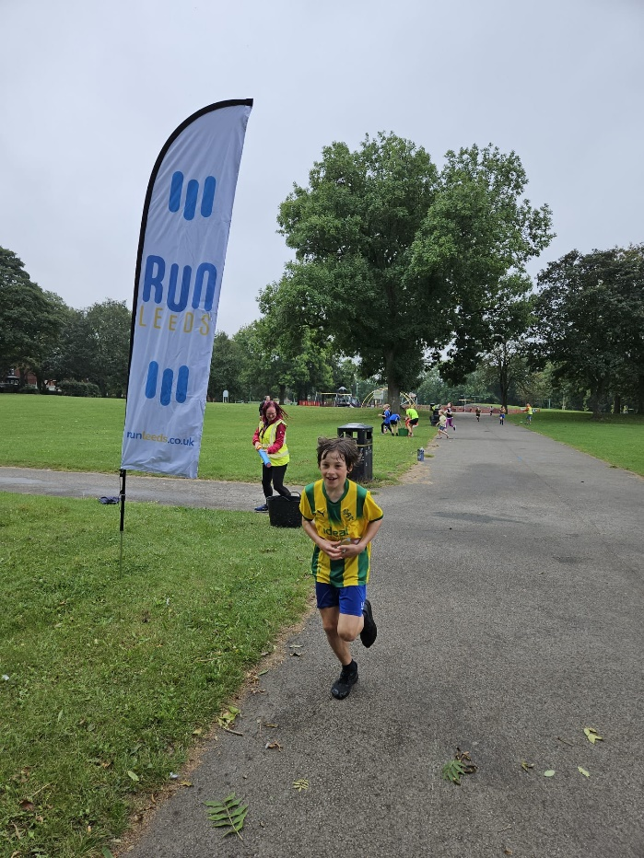

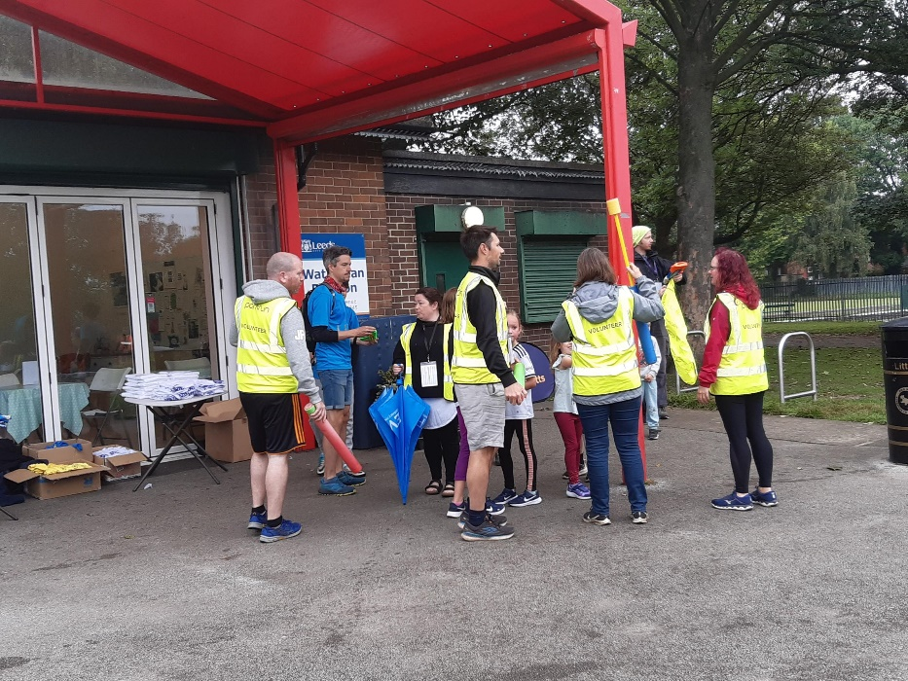

A huge thanks to the Café in the park, allowing us to use their outdoor space and store all our equipment over the weekend. Also, massive thanks as well to Phil Hodgson, the Cross Flatts Junior Parkrun volunteers and the South Leeds Lakers who supported. Little did they know that they would also be getting soaked!

**The Feedback**

*Just to say a massive thank you for Sunday. I’m not sure who enjoyed it most in the adults and kids, it was great fun.*

*These things don’t just happen without a lot of hard work in the background, and everyone is appreciative of your efforts.  The work you do in the area helps makes a real difference to our community.*

*Thank you*

*Phil*

